Anxiety Toolbox
Student Workbook

Drexel University Counseling Services (215) 895-1415
www.drexel.edu/ counselingandhealth

Table of Contents

Welcome Page 3
Frequently Asked Questions Page 4
In Session Worksheets Page 5
Session 1: Anxiety 101 Page 6
Stress vs. Anxiety Page 6
Threat System (Fight or Flight) Page 7
Cross Sectional Formulation (example) Page 8
Cross Sectional Formulation (blank) Page 9
Common Anxiety Symptoms Page 10
Feelings Wheel Page 11
Sleep Hygiene Page 12
Session 1 Homework Assignment Page 13
Cross Sectional Formulation (blank) Pages 14-16 Session 2: Automatic Thoughts & Unhelpful Cognitions Page 17
Unhelpful Thinking Styles Page 18
Cross Sectional Formulation (example) Page 19
Identifying Triggers Worksheet Page 20
Session 2 Homework Assignments Page 21
Homework: Identifying Triggers Pages 22-23
Cross Sectional Formulation (blank) Pages 24-26 Session 3: Putting it All Together Page 27
Alternative Response Worksheet (example) Page 28 If you're having trouble, ask yourself these questions Pages 29-30
Alternative Response Worksheet (blank) Pages 31-33
Putting it All Together: My Anxiety Treatment Plan Pages 34-35 Appendix Page 36
Understanding Anxiety Disorders Page 37
Grounding Exercises Pages 38-39
Breathing Exercises Page 40
Pleasant Activities Page 41

Welcome!
Welcome to Anxiety Toolbox, a fast-paced, 3-session seminar intended to help increase your understanding and knowledge about anxiety. The goal is to provide you with some skills to recognize and manage symptoms you may be experiencing. We hope you find it helpful.

The goal of this seminar is to provide you with life-long tools you can use while facing anxiety-triggering situations. Remember, this intervention is not intended to “get rid of” your anxiety. While occasionally unpleasant, some anxiety can actually be a helpful and motivating emotion. Our hope is that these three sessions provide you with a jumping board from which to integrate skills into your daily life in the service of reducing anxiety.

By the end of this course, you will have received a lot of information and at times it may feel overwhelming. Remember that like any skill (e.g., learning to ride a bike), the skills you will learn in Anxiety Toolbox take time and practice to master. At times, you may encounter obstacles and/or find it difficult to integrate these skills into your daily life.
That’s okay, it’s how change works, and as with all change, it’s important to practice as much as you can, even after encountering setbacks.

Think of your practice of these skills as a form of “mental health hygiene.” At the outset, it may seem tedious and you may question why you need to practice these skills so often.
Think of it like dental hygiene—you brush your teeth multiple times a day to prevent the buildup of plaque and ultimately to prevent cavities. Similar to brushing your teeth, daily practice prevents a buildup of anxiety and stress over time. The more you practice and use these skills as part of your daily routine, the less tedious they may seem because they simply become a regular part of daily life.

Should you wish to focus more in depth on any of your anxiety related concerns, you may debrief with a therapist following completion of Anxiety Toolbox to discuss options.

If at any time you feel that you need additional support, contact Counseling Services at (215)-895-1415. You may also find additional resources online at http://www.drexel.edu/counselingandhealth

Frequently Asked Questions (FAQ)

What is Anxiety Toolbox?
Anxiety Toolbox is a fast-paced three-session seminar specifically designed to help people who struggle with a variety of anxiety-related concerns (e.g., panic attacks, Generalized Anxiety, test anxiety). The goal of this seminar is to provide education on anxiety and to teach coping skills for managing anxiety symptoms.

Why does Anxiety Toolbox use a 3-session model?
Teaching Anxiety Toolbox over the course of 3 sessions allows you sufficient time to learn the concepts with time to practice between sessions. Keeping it to three sessions allows you to find time in your busy schedule to learn these skills.

Why do I have to do homework?
The focus of this workshop is on building skills to cope with anxiety; in order to achieve that goal, regular practice is essential. The more you practice, the more you may find you get out of this workshop. The assignments are for you and only you, in the service of your own personal growth. You will not be required to provide your responses at any time during this workshop; however, it’s important to bring your responses as you may be asked to look back on or elaborate on a prior assignment during the workshop.

IN SESSION WORKSHEETS

SESSION 1: ANXIETY 101
Stress versus Anxiety

Everyday Anxiety (Stress) | Anxiety Disorder
In response to a known environmental factor | In response to an unknown source or in response to the experience of stress
Symptoms go away when the stressor goes away | Symptoms remain despite no identifiable stressor
Worry about living away from home for the first time, passing a class, a romantic breakup, or other important life events | Constant and unsubstantiated worry that causes significant distress and interferes with your daily life
Embarrassment or self-consciousness in an uncomfortable or awkward social situation; feeling nervous about meeting new people | Avoidance of social situations due to fear of being judged, embarrassed, or humiliated
Feeling nervous or sweating before a big test, class presentation, stage performance, or other significant event | Panic attacks that seem out of the blue and preoccupation with the fear of having another one
Realistic fear of a dangerous object, place, or situation (e.g. fear of poisonous snakes) | Irrational fear or avoidance of an object, place, or situation that poses little or no threat of danger (e.g. fear of elevators)
Making sure that you are healthy and living in a safe environment | Performing uncontrollable repetitive actions, such as excessive cleaning, checking, touching or arranging

Adapted from: http://www.adaa.org/understanding-anxiety

Page 7 Anxiety Toolbox Workbook

Cross Sectional Formulation
Situation (When? Where? What? With whom? What did you feel anxious about?)
A student invited me to a party in my residence hall, but I didn’t know her very well and felt anxious about going.
Physical (When anxious, what physical sensations did you experience? What did you notice in your body?)
Heart racing, tight chest, shallow breathing

Emotional (What emotions came up for you when you felt anxious?)
Anxious, scared, ashamed, lonely
Cognitive (What went through your mind when you felt anxious? What did that say or mean about you or the situation?)
I won’t know anyone at the party and will feel awkward. No one will like me because I’m so socially awkward. I won’t have fun. But if I say no, this person won’t like me and I wouldn’t make friends.

Behavioral (What was your first instinct and/or automatic response? What did you do and/or avoid doing at the time?)
My first instinct was to say no, but instead, I said I’ll think about it. I never got back to her and didn’t go to the party.

Page 8 Anxiety Toolbox Workbook

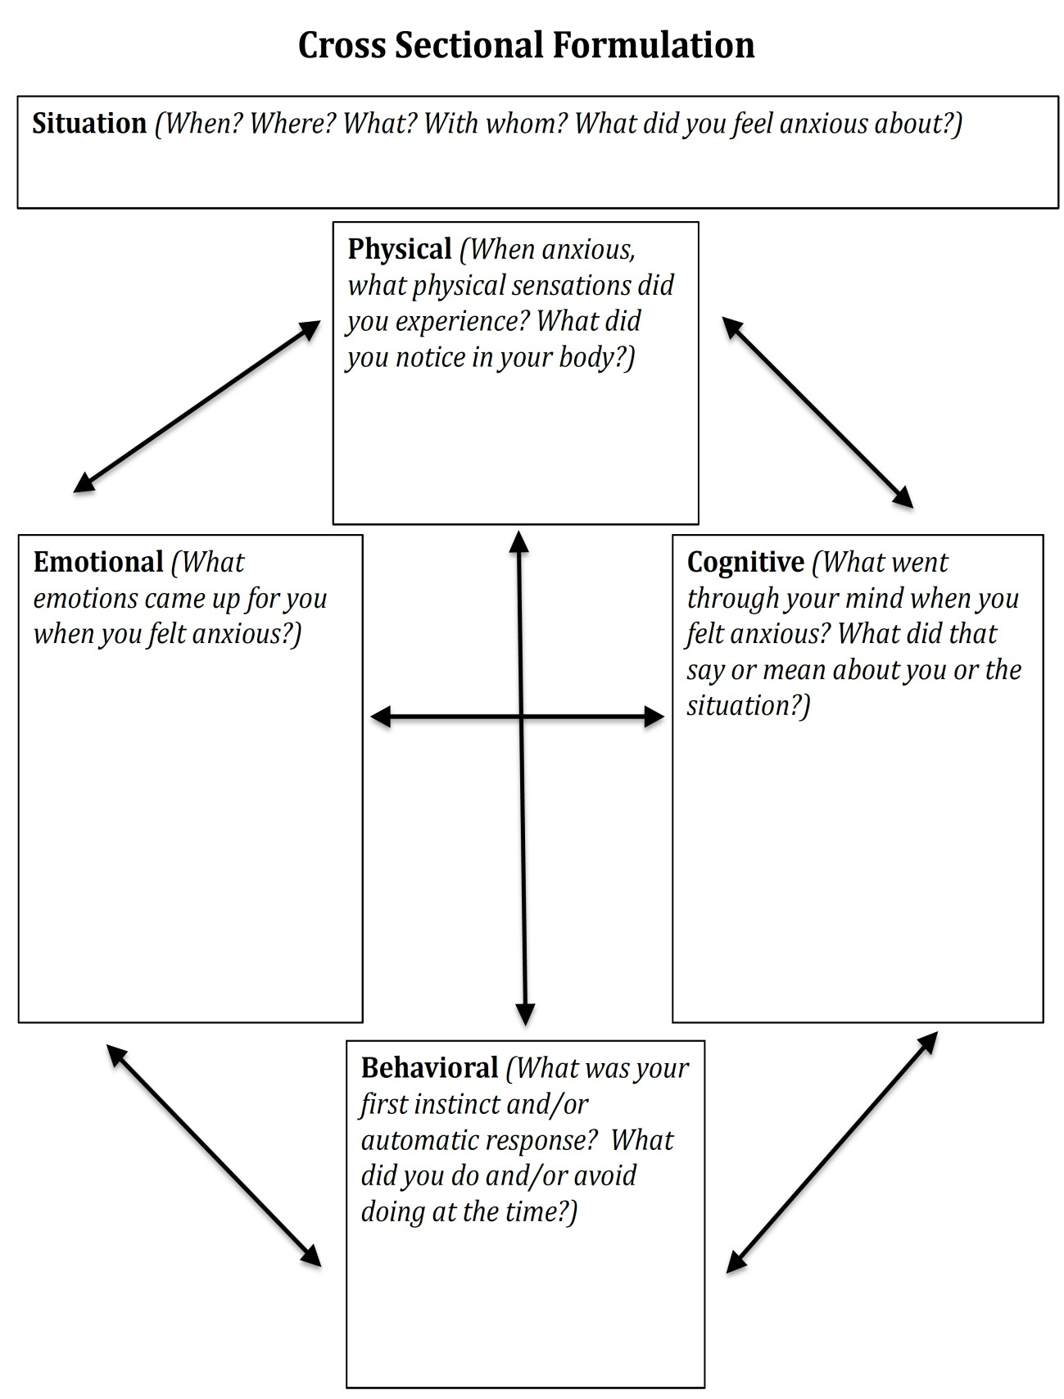

Common Anxiety Symptoms

Physical Symptoms
- Increased heart rate
- Shortness of breath
- Chest pain or pressure
- Choking sensation
- Dizziness, lightheadedness
- Sweating, hot flashes, chills
- Nausea, upset stomach, diarrhea
- Trembling, shaking
- Weakness, unsteadiness, faintness
- Tense muscles, rigidity
- Dry mouth
- Other:

Behavioral Symptoms
- Avoidance of threat cues or situations
- Escape, flight
- Pursuit of safety, reassurance
- Restlessness, agitation, pacing
- Hyperventilation
- Freezing, motionlessness
- Difficulty speaking
- Other:

Cognitive Symptoms
- Fear of losing control, being unable to cope
- Fear of physical injury or death
- Fear of “going crazy”
- Fear of negative evaluations by others
- Frightening thoughts, images, or memories
- Perceptions of unreality or detachment
- Poor concentration, confusion, distractibility
- Narrowing of attention, hypervigilance for threat
- Poor memory
- Difficulty in reasoning, loss of objectivity
- Other:

Emotional Symptoms
- Feeling nervous, tense, wound up
- Feeling frightened, fearful, terrified
- Being edgy, jumpy, jittery
- Being impatient, frustrated
- Other:

Adapted from The Anxiety and Worry Workbook by Clark and Beck

Feelings Wheel

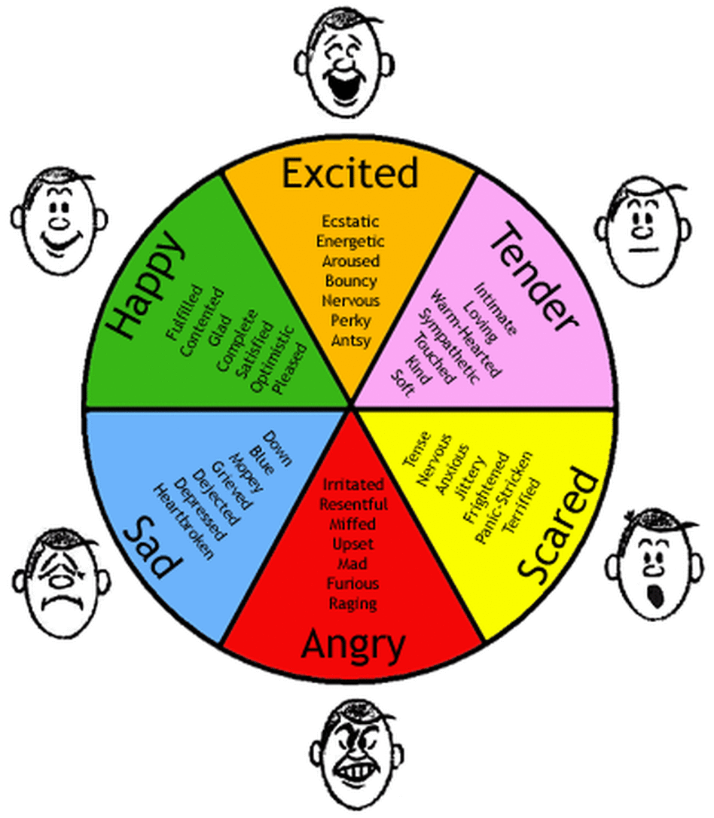

sleephygiene
  - No naps. It is best to avoid taking naps

What is Sleep Hygiene?

‘Sleep hygiene’ is the term used to describe good sleep habits. Considerable research has gone into developing a set of guidelines and tips which are designed to enhance good sleeping, and there is much evidence to suggest that these strategies can provide long-term solutions to sleep difficulties.

There are many medications which are used to treat insomnia, but these tend to be only effective in the short-term. Ongoing use of sleeping pills may lead to dependence and interfere with developing good sleep habits independent of medication, thereby prolonging sleep difficulties. Talk to your health professional about what is right for you, but we recommend good sleep hygiene as an important part of treating insomnia, either with other strategies such as medication or cognitive therapy or alone.

Sleep Hygiene Tips
- Get regular. One of the best ways to train your body to sleep well is to go to bed and get up at more or less the same time every day, even on weekends and days off! This regular rhythm will make you feel better and will give your body something to work from.
- Sleep when sleepy. Only try to sleep when you actually feel tired or sleepy, rather than spending too much time awake in bed.
- Get up & try again. If you haven’t been able to get to sleep after about 20 minutes or more, get up and do something calming or boring until you feel sleepy, then return to bed and try again. Sit quietly on the couch with the lights off (bright light will tell your brain that it is time to wake up), or read something boring like the phone book. Avoid doing anything that is too stimulating or interesting, as this will wake you up even more.
- Avoid caffeine & nicotine. It is best to avoid consuming any caffeine (in coffee, tea, cola drinks, chocolate, and some medications) or nicotine (cigarettes) for at least 4-6 hours before going to bed. These substances act as stimulants and interfere with the ability to fall asleep
- Avoid alcohol. It is also best to avoid alcohol for at least 4-6 hours before going to bed. Many people believe that alcohol is relaxing and helps them to get to sleep at first, but it actually interrupts the quality of sleep.
- Bed is for sleeping. Try not to use your bed
for anything other than sleeping and sex, so that your body comes to associate bed with sleep. If you use bed as a place to watch TV, eat, read, work on your laptop, pay bills, and other things, your body will not learn this connection.
during the day, to make sure that you are tired at bedtime. If you can’t make it through the day without a nap, make sure it is for less than an hour and before 3pm.
  - Sleep rituals. You can develop your own rituals of things to remind your body that it is time to sleep - some people find it useful to do relaxing stretches or breathing exercises for 15 minutes before bed each night, or sit calmly with a cup of caffeine-free tea.
  - Bathtime. Having a hot bath 1-2 hours before bedtime can be useful, as it will raise your body temperature, causing you to feel sleepy as your body temperature drops again. Research shows that sleepiness is associated with a drop in body temperature.
  - No clock-watching. Many people who struggle with sleep tend to watch the clock too much. Frequently checking the clock during the night can wake you up (especially if you turn on the light to read the time) and reinforces negative thoughts such as “Oh no, look how late it is, I’ll never get to sleep” or “it’s so early, I have only slept for 5 hours, this is terrible.”
  - Use a sleep diary. This worksheet can be a useful way of making sure you have the right facts about your sleep, rather than making assumptions. Because a diary involves watching the clock (see point 10) it is a good idea to only use it for
two weeks to get an idea of what is going and then perhaps two months down the track to see how you are progressing.
  - Exercise. Regular exercise is a good idea to help with good sleep, but try not to do strenuous exercise in the 4 hours before bedtime. Morning
walks are a great way to start the day feeling refreshed!
  - Eat right. A healthy, balanced diet will help you to sleep well, but timing is important. Some people find that a very empty stomach at bedtime is distracting, so it can be useful to have a light snack, but a heavy meal soon before bed can also interrupt sleep. Some people recommend a warm glass of milk, which contains tryptophan, which acts as a natural sleep inducer.
  - The right space. It is very important that your bed and bedroom are quiet and comfortable for sleeping. A cooler room with enough blankets to stay warm is best, and make sure you have curtains or an eyemask to block out early morning light and earplugs if there is noise outside your room.
  - Keep daytime routine the same. Even if you have a bad night sleep and are tired it is important that you try to keep your daytime activities the same as you had planned. That is, don’t avoid activities because you feel tired. This can reinforce the insomnia.

This document is for information purposes only. Please refer to the full disclaimer and copyright statement available at http://www.cci.health.wa.gov.au regarding the information from this website before making use of such information.
See website www.cci.health.wa.gov.au for more handouts and resources.

entre for
linical
Interventions
CC

•Psychotherapy•Research•Training

Session 1: Homework Assignment

Homework 1: Complete at least 1 Simple Cross Sectional Formulation worksheet for review next week (multiple blank copies provided starting on page 14)

Homework 2: Practice Deep Breathing Homework 3: Implement 1 Sleep Hygiene Tip

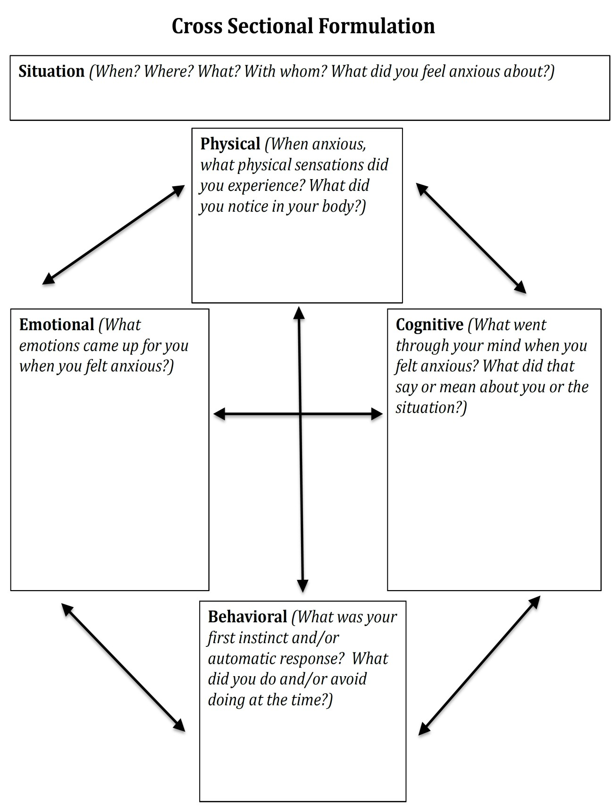

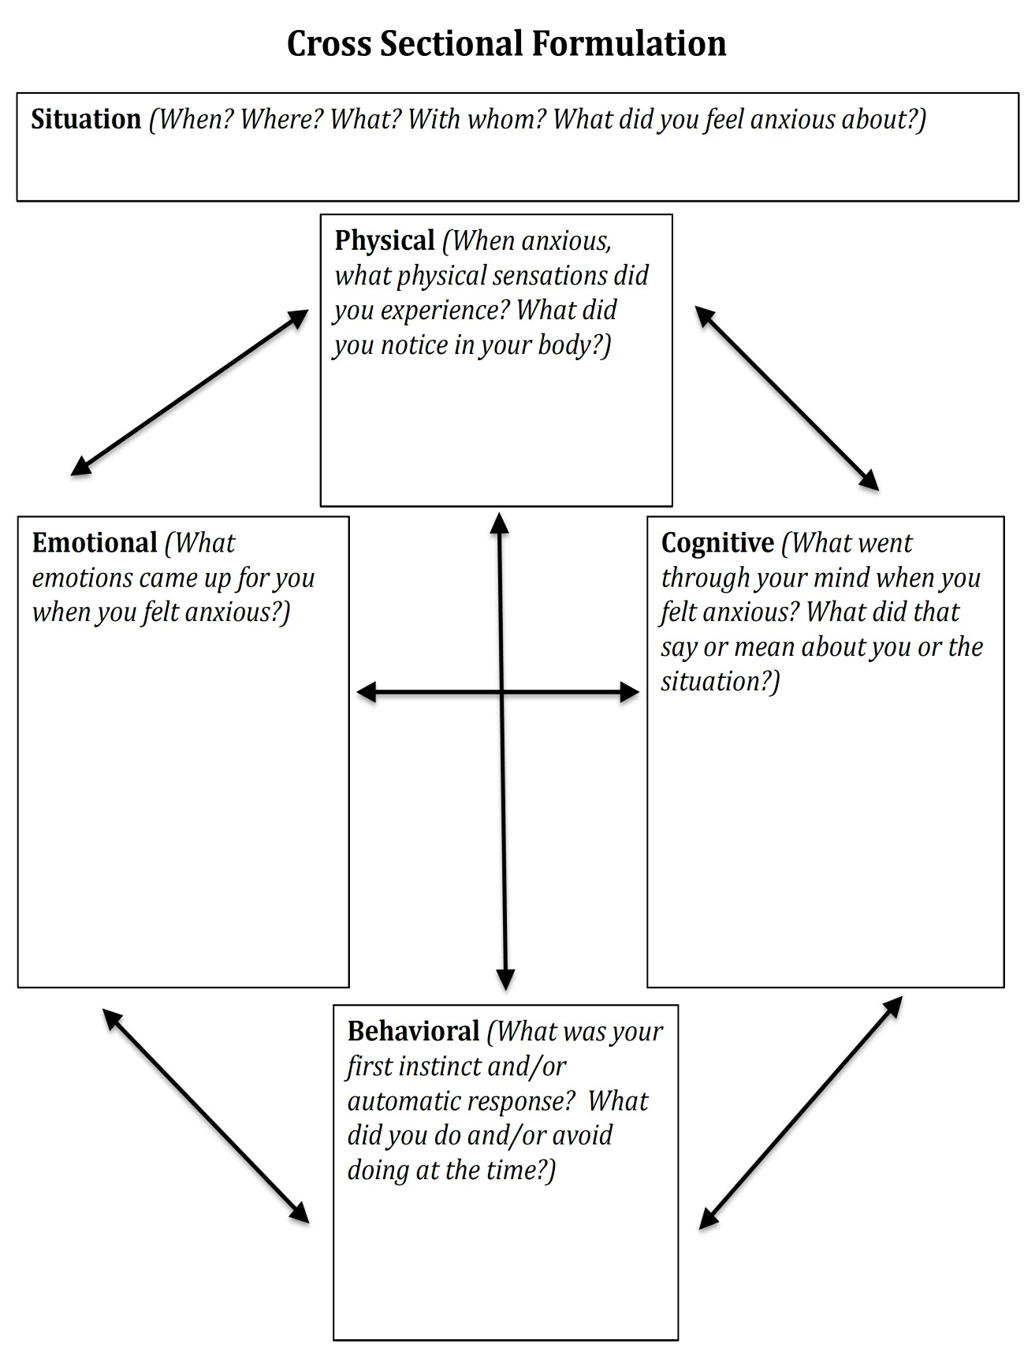

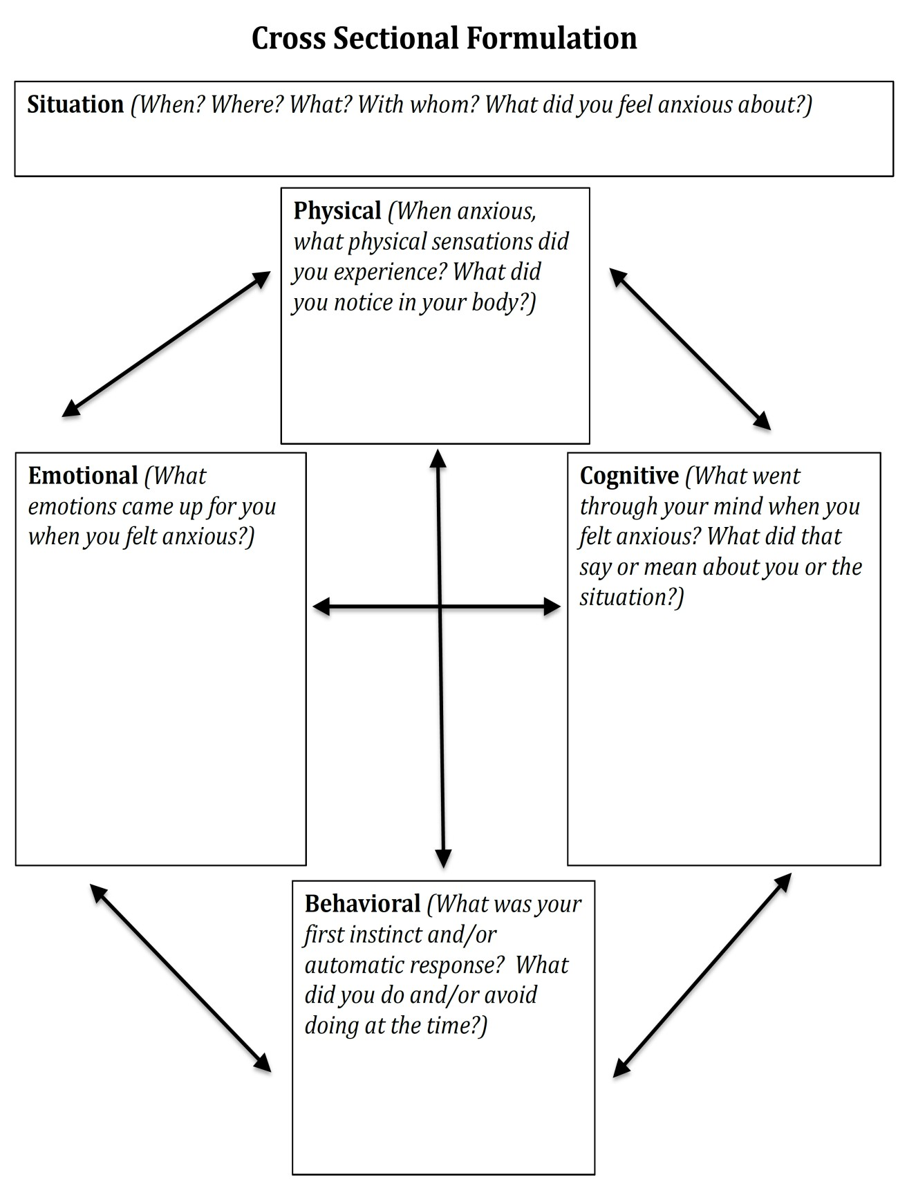

SESSION 2: AUTOMATIC THOUGHTS
AND UNHELPFUL COGNITIONS

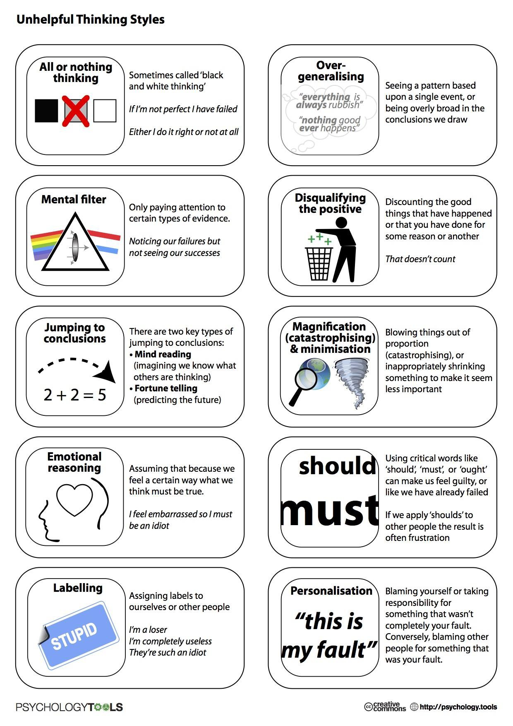

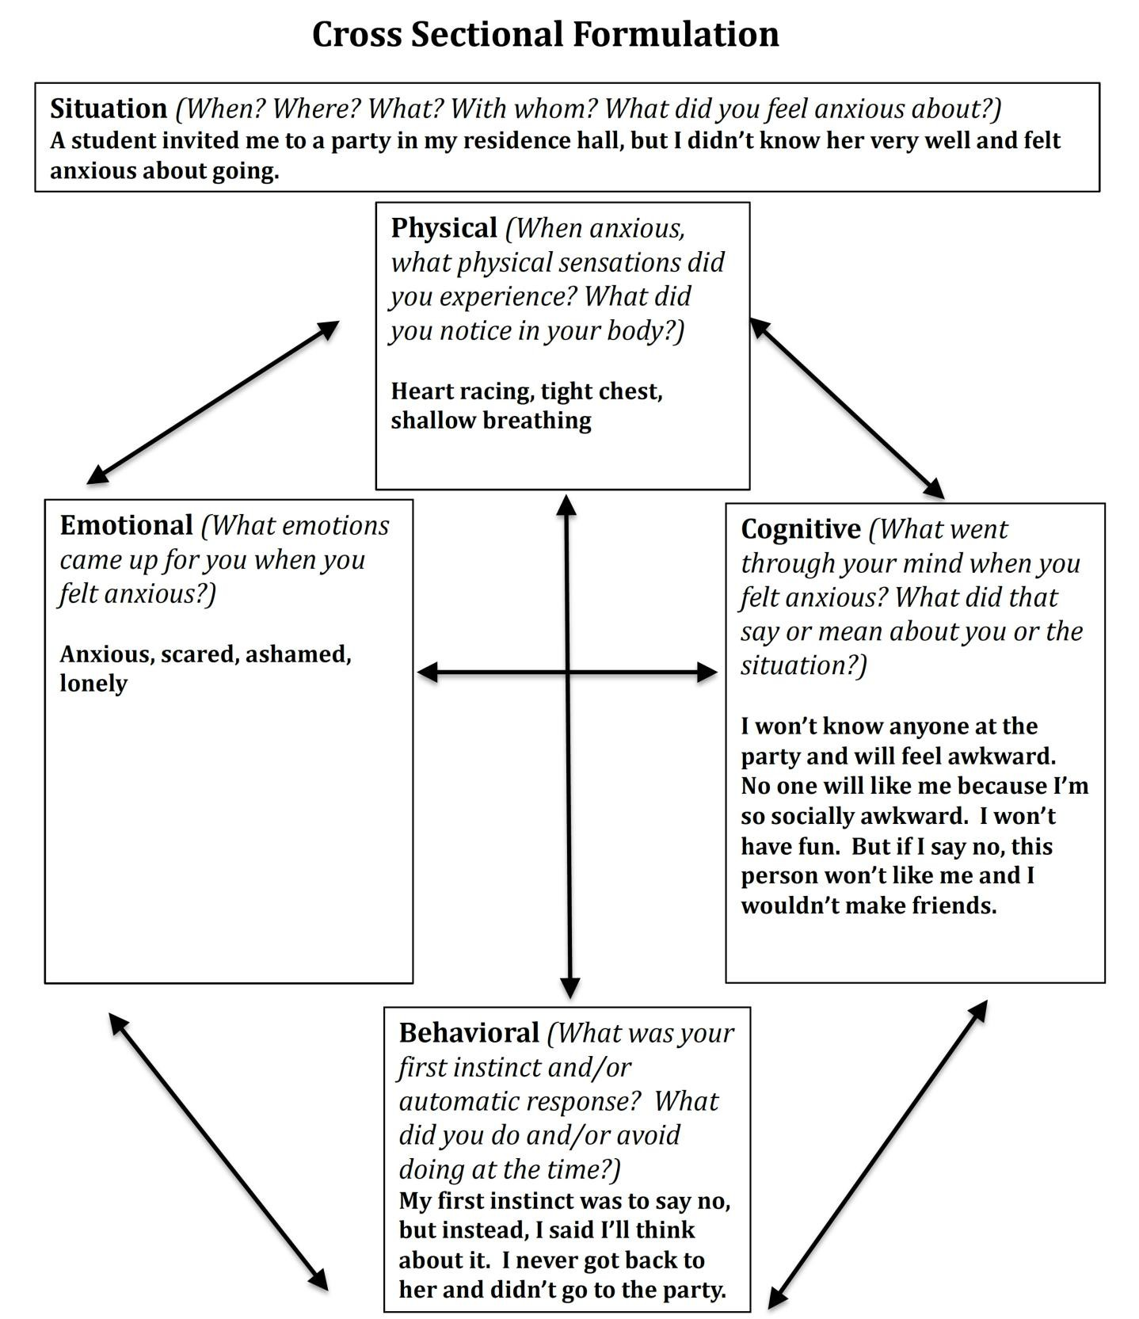

Identifying Triggers Worksheet

While at times it may be difficult to identify a trigger, understanding your triggers for anxiety is an important step in helping you know when to implement and/or emphasize practice of the coping strategies you will learn in Anxiety Toolbox. Triggers can be external events (e.g., a test) or internal stimuli (e.g., a physical sensation or emotion) that led to your experience of anxiety (i.e., the emotional, physical, cognitive, and behavioral symptoms previously discussed during this workshop). Remember that sometimes the symptoms themselves can be a trigger that starts the cycle of anxiety.
The following are some typical categories in which triggers might appear with examples: Responses to Internal Stimuli:
- Emotions: e.g., feeling down, fear or worry
- Mental Images: e.g., replaying interpersonal interactions or performance experience
- Physical State: e.g., racing heartbeat, lightheadedness, tightness in chest
- Thoughts: e.g., “I might fail this test”, “That person must not like me”, “If someone talks to me in class, I won’t be able to handle it.”

Responses to External Stimuli:
- Presence of Others: e.g., attending a social event, meeting with a professor, spending time with roommates, family interactions
- Physical Setting: e.g., a classroom, open areas on campus, inside a car
- Social Pressure: e.g., feeling pressured to make friends, feeling pressured to perform well in school (in comparison to your peers)
- Activities: e.g., a sports event, a party, going home for the weekend

List some triggers you experience related to your anxiety:
1.
2. _
3.
4.
5.
6.
7.
8.
9. _
10.

Session 2 Homework Assignments

Homework 1: Complete Identifying Triggers Worksheet on page 22-23

Homework 2: Complete at least 1 Simple Cross Sectional Formulation worksheet for review next week (multiple blank copies provided starting on page 24)

Homework: Identifying Triggers

Pay attention to any triggers for anxiety that you may experience over the next week. Write them down in the following categories. You may have triggers in all of the categories or you may notice triggers in only one or two categories. (Use the “other” category for triggers you feel don’t fit in the options listed.)

Emotions:
1.
2.
3. _

Mental Images:
1.
2. _
3.

Physical States:
1. _
2.
3.

Thoughts:
1. _
2.
3. _

Presence of Others:
1.
2.
3.

Physical Setting:
1.
2.
3.

Social Pressure:
1.
2. _
3.

Activities:
1.
2.
3.

Other:
1. _
2.
3.
4.
5. _

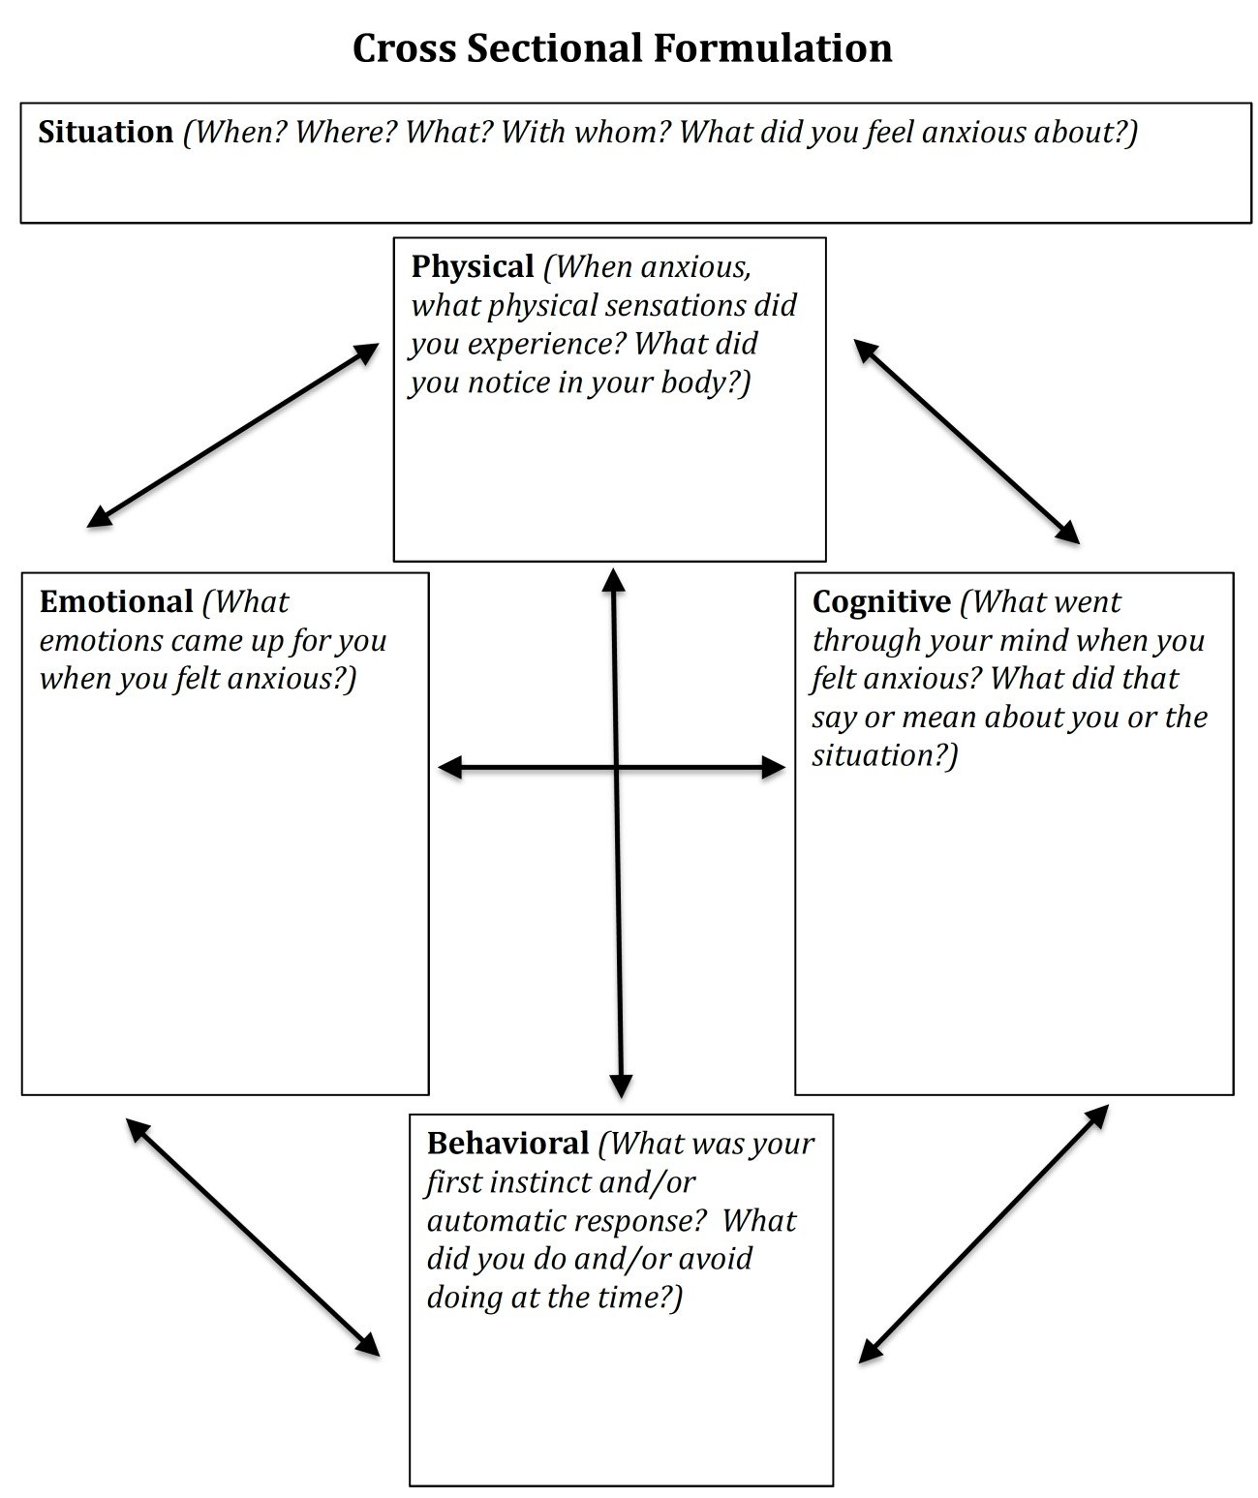

SESSION 3: ALTERNATIVE RESPONSES,
GROUNDING, AND SELF- CARE; PUTTING IT ALL TOGETHER

Alternative Response Worksheet
Situation: (When? Where? What? With whom? What did you feel anxious about?)

A student invited me to a party in my residence hall, but I didn’t know her very well and felt anxious about going.

Alternative Thoughts and Images: (Are these thoughts helpful? Are the anxious thoughts 100% true/accurate, 100% of the time? What are other ways of looking at this? What is the bigger picture? )  I may not be as socially awkward as I think.  If she invited me, she probably wants me there.  I might still have an okay time even if I am anxious | Alternative Behaviors: (What could you do that would be more helpful for you, others, &/or the situation? What are coping strategies that might be helpful?)  Coping Strategies I Can Use:  - Deep breathing  - Distract myself  - Seek support from a friend/ family member  - Do a pleasurable activity  - Use alternative response worksheet | Alternative Feelings: (What are feelings that are more helpful? What if you acted and thought differently about the situation? How might these changes help you feel differently?)  Excited Wanted Liked Hopeful
Outcome: (What was the original outcome? Using these new alternatives, what would you like the outcome to be in the future?)
Original outcome, I stayed in my room and watched Netflix. Next time, I want to go to the party so that I can make friends. If I feel too uncomfortable, I can always leave.

If you're having trouble, ask yourself these questions:

Whenever we recognize an anxiety-related thought, feeling or behavior, it can be very helpful to ask ourselves the following questions:

Alternative THOUGHTS:
    - What are other ways of looking at this situation?
    - Am I looking at the whole picture?
    - What might be a more helpful way of picturing this situation?
    - What unhelpful thinking styles might I be using here (see below)?
    - What is the evidence that my thoughts are true? Is there an alternative way of thinking about this situation that is more true?
    - What is the probability that my thoughts will happen? What are some other things that could happen that are equally, if not more, probable?
    - Have I had any experiences in the past that suggests that this thought might not be COMPLETELY true ALL of the time?
    - Can I really predict the future? Is it helpful to try? What is more helpful?
    - Am I exaggerating how bad the result might be? What is more realistic?
    - Can I read people’s minds? What else might they be thinking (that’s not so negative)?
    - If a friend or loved one were in this situation and had this thought, what would I tell them?

Common Cognitive Distortions (Unhelpful Thinking Styles)
All or Nothing Thinking: thinking in absolute, black and white categories | Over-generalizing: seeing a pattern based upon a single event or being overly broad in conclusions we draw
Mental Filter: only paying attention to certain types of evidence (e.g., dwelling on the negatives) | Disqualifying the positive: discounting the good things that have happened
Jumping to Conclusions:  Mind reading: imagining we know what others are thinking  Fortune telling: predicting the future | Magnification (catastrophizing) and minimization: blowing things out of proportion or inappropriately shrinking something to make it seem less important
Emotional Reasoning: assuming because we feel a certain way, what we think must be true | Should/Must Thinking: Using words like “should”, “must”, “ought to” or “have to”
Labeling: assigning labels to ourselves or others | Personalization: blaming yourself for something you weren’t entirely responsible for OR blaming others and overlooking ways you may have contributed to the outcome

Alternative FEELINGS:
- What might it feel like if I acted/thought differently?
- When I’m not feeling this way, do I think about this situation differently?
- Are there any strengths or positives in me or the situation that I might be ignoring?
- What else might this anxiety be related to? Is it really about feeling ?
- Tell yourself: “This feeling will pass. It’s a normal body reaction.”
- Breathe: Focus your attention on your breathing. Imagine you have a balloon in your belly, inflating on the in-breath, deflating on the out-breath.

Alternative BEHAVIORS:
- What could I do in the moment that would be more helpful?
- What’s the best thing to do (for me, for others, or for the situation)?
- If my feared situation happens, how will I cope? What coping skills can I use to handle my feared situation? What have I done in the past that was successful?
- Am I needing to work on acceptance, letting go of control, being okay with less than perfect, or having faith in the future and myself?

Alternative Response Worksheet
Situation (When? Where? What? With whom? What did you feel anxious about?)

Alternative Thoughts and Images: (Are these thoughts helpful? Are the anxious thoughts 100% true/accurate, 100% of the time? What are other ways of looking at this? What is the bigger picture? ) | Alternative Behaviors: (What could you do that would be more helpful for you, others, &/or the situation? What are coping strategies that might be helpful?)  Coping Strategies I Can Use:  - Deep breathing  - Distract myself  - Seek support from a friend/ family member  - Do a pleasurable activity  - Use alternative response worksheet | Alternative Feelings: (What are feelings that are more helpful? What if you acted and thought differently about the situation? How might these changes help you feel differently?)
Outcome: (What was the original outcome? Using these new alternatives, what would you like the outcome to be in the future?)

Alternative Response Worksheet
Situation: (When? Where? What? With whom? What did you feel anxious about?)

Alternative Thoughts and Images: (Are these thoughts helpful? Are the anxious thoughts 100% true/accurate, 100% of the time? What are other ways of looking at this? What is the bigger picture? ) | Alternative Behaviors: (What could you do that would be more helpful for you, others, &/or the situation? What are coping strategies that might be helpful?)  Coping Strategies I Can Use:  - Deep breathing  - Distract myself  - Seek support from a friend/ family member  - Do a pleasurable activity  - Use alternative response worksheet | Alternative Feelings: (What are feelings that are more helpful? What if you acted and thought differently about the situation? How might these changes help you feel differently?)
Outcome: (What was the original outcome? Using these new alternatives, what would you like the outcome to be in the future?)

Alternative Response Worksheet
Situation: (When? Where? What? With whom? What did you feel anxious about?)

Alternative Thoughts and Images: (Are these thoughts helpful? Are the anxious thoughts 100% true/accurate, 100% of the time? What are other ways of looking at this? What is the bigger picture? ) | Alternative Behaviors: (What could you do that would be more helpful for you, others, &/or the situation? What are coping strategies that might be helpful?)  Coping Strategies I Can Use:  - Deep breathing  - Distract myself  - Seek support from a friend/ family member  - Do a pleasurable activity  - Use alternative response worksheet | Alternative Feelings: (What are feelings that are more helpful? What if you acted and thought differently about the situation? How might these changes help you feel differently?)
Outcome: (What was the original outcome? Using these new alternatives, what would you like the outcome to be in the future?)

Putting it all Together: My Anxiety Treatment Plan

- My primary anxiety symptoms include:

  - Emotional:

  - Physical:

  - Cognitive:

  - Behavioral:

- Some of my unhelpful ways of thinking are: (e.g., all or nothing thinking, catastrophizing, etc.)

- My situational and cognitive triggers are: (e.g., unfamiliar situations, negative thoughts, etc.)

- The most helpful grounding techniques:

- The most helpful relaxation exercise:

- The best time and place to practice relaxation exercises:

- When I feel overwhelmed, it is helpful for me to:

- Positive changes I can make to help my sleep include: (e.g., no TV 30 minutes before bed, wake up at the same time daily, turn phone off, etc.)

- MY GOALS: Name 2 goals you would like to achieve over the next few months, related to anxiety and self-care. Think: specific, achievable, and measurable.

  - Name 2 goals you would like to achieve related to ANXIETY (e.g., Thinking about the strategies you find most helpful, what would you like to try, how often, when, etc.?)

  - Name 2 goals you would like to achieve related to SELF-CARE: (What will your self-care look like over the next few months? These could be goals related to nutrition, exercise, sleep, schoolwork, leisure activities, etc.)

APPENDIX

Understanding Anxiety Disorders
While anxiety is a normal and adaptive experience for everyone, anxiety disorders are characterized by significant distress or impairment in social, academic/occupational, or other important areas of functioning (e.g., your general ability to function in life).

Some of the most common anxiety disorders include:

Generalized Anxiety Disorder: Chronic and unrealistic worry that feels difficult to
control about everyday things (i.e., things that do not worry most people)

Social Anxiety Disorder: Chronic worry solely related to social situations

Panic Disorder: Characterized by episodes of “panic” that include things like: adrenaline surge, fear of losing control, chest pain, racing heart, shortness of breath, dizziness

Phobias: Specific fears that are excessive in nature and often lead to avoiding that which is feared (e.g., public speaking, heights, tunnels, etc.)

Obsessive-Compulsive Disorder: Excessive rumination (thinking) with repetitive
behaviors to reduce anxiety

Grounding Exercises

When people become overwhelmed with distressing thoughts or feelings, including intense anxiety, activities that keep your mind and body connected (called “grounding”) can be helpful in regaining a sense of stability and mental focus. The following are a number of grounding exercises to choose from to help firmly anchor you in the present moment and provide you with space to choose where to focus your energy. You may need to try multiple different exercises to find one or two that work best for you.

- Remind yourself of who you are now. State your name, age and where you are right now.

- Take ten slow deep breaths. Focus your attention on each breath on the way in and on the way out. Say the number of the breath to yourself as you exhale.

- Splash water on your face or place a cool wet cloth on your face.

- Pay purposeful attention as you hold a cold (non-alcoholic) beverage in your hands. Feel the coldness, and the wetness on the outside. Note the taste as you drink. You can also do this exercise with a warm beverage.

- Find a “grounding object” to hold, look at, listen to, and/or smell. This could be a soft object such as a pillow or stuffed animal, a smooth stone you found on the beach, a picture of a beautiful scene or loved one, and/or any other object that represents safety or comfort.

- Listen to music. Pay close attention and listen for something new or different.

- If you wake up suddenly during the night and feel disoriented or distressed, remind yourself who you are and where you are. Look around the room and notice familiar objects and name them. Feel the bed you are lying on, the softness of the sheets or blankets, the warmth or coldness of the air, and notice any sounds you hear. Remind yourself that you are safe.

- Feel the clothes on your body, whether your arms and legs are covered or not, and the sensation of your clothes as you move in them.

- While sitting, feel the chair under you and the weight of your body and legs pressing down on it.

- If you are lying down, feel the contact between your head, your body and your legs, as they touch the surface you are lying on. Starting from your head, notice how each part feels, all the way down to your feet, on the soft or hard surface.

- Stop, look, and listen. Notice and name what you can see and hear nearby and in the distance.

- Look around you, notice what is front of you and to each side, name first large objects and then smaller ones.

- Get up, walk around, take your time to notice each step as you take one then another.

- If you can, step outside, notice the temperature, the sounds around you, the ground under your feet, the smell in the air, etc.

- “54321” Grounding Exercise:
  - Name 5 things you can see in the room with you.
o Name 4 things you can feel (tactile; e.g. “chair on my back” or “feet on floor”)
  - Name 3 things you can hear right now
  - Name 2 things you can smell right now
  - Name 1 good thing about yourself
- Write and/or say grounding statements
  - This situation won’t last forever
  - This too shall pass.
  - I can ride this out and not let it get me down.
  - My anxiety/fear/sadness won’t kill me; it just doesn’t feel good right now.
  - These are just my feelings and eventually they’ll go away.

Adapted from: http://www.livingwell.org.au/well-being/grounding-exercises/

Breathing Exercises Belly (or Diaphragmatic) Breathing
You can do this exercise in any position, but it is helpful to do this exercise while lying down when first learning belly breathing.

- Lie comfortably on your back, with a pillow under your head, your knees bent and your back flat. You can stretch your legs out if that's more comfortable.
- Place one hand on your belly and one hand on your upper chest.
- Inhale slowly and expand your belly as you breathe so that your lower hand moves with your belly. The hand on your chest should remain as still as possible.
- Slowly exhale, focusing on the movement of your belly and lower hand as it returns to its original position.
- Repeat steps 3 & 4 for several minutes, always focusing on the movement of the belly as you breathe. If your mind wanders, gently bring your attention back to your breathing.

Breath-Counting Exercise
This exercise focuses on the use of counting with the rhythm of the breath. Start with a short period of time and gradually increase the time. Set a timer so that you do not have to worry about when to stop.

- Find a comfortable position. Take several deep breaths and settle into yourself. You may either close your eyes or keep them open, depending on your own comfort. If you keep them open, fix them on an object or a spot on the floor about four feet in front of you. Your eyes may be either focused or unfocused.
- Take deep, comfortable breaths. Notice your inhalation. The pause between inhaling and exhaling, your exhalation, and the pause before starting again.
- As you inhale, count, “one...” As you exhale, count, “two...” Inhale, “three...” Exhale, “four...” Continue until you reach 10 then start over.
- If you lose count, simply begin with “one” on your next inhalation.
- If you notice your mind has wandered, gently notice this, and return your focus back to counting your breath.
- If you notice any body sensations catching your attention, focus on that sensation until it fades. Then return your attention back to counting your breaths.

Pleasant Activities

Acting | Amusing people | Attending a concert | Beachcombing | Being alone | Being with animals | Being at the beach
Being complimented | Being coached | Being counseled | Being in the country | Being at a family get- together | Being at a fraternity/ sorority | Being with friends
Being with happy people | Being in the mountains | Being with my roommate | Being with someone I love | Being told I am loved | Being with my parents | Bird- watching
Boating/ canoeing | Budgeting my time | Buying things for myself | Buying something for someone I care about | Camping | Caring for plants | Canning/ Making preserves
Cheering for something | Collecting things | Combing/ brushing my hair | Completing a difficult task | Complimenting or praising someone | Cooking | Counseling someone
Dancing | Dating someone I like | Designing/ Drafting | Discussing my favorite hobby | Doing art work | Doing experiments | Doing favors for people I like
Doing housework | Dreaming at night | Driving long distances | Eating good meals | Exploring/ Hiking | Expressing love to someone | Feeling the presence of a Higher Power
Fishing | Fixing machines | Gardening/ Doing yardwork | Gathering natural objects | Giving gifts | Giving a party for someone | Getting up early
Getting massages | Giving massages | Going to an amusement park/ zoo | Going to a barber/ beautician | Going to a concert | Going to lectures | Going to a luncheon/ potluck
Going to a health club/ sauna/spa | Going to the movies | Going to a museum | Going on nature walks/ field trips | Going to a play | Going to a restaurant | Going to a reunion
Going to a spiritual/ peaceful place | Going to a sports event | Having coffee/tea with friends | Having daydreams | Having friends over to visit | Having a lively talk | Having lunch with friends
Having an original idea | Having spare time | Hearing jokes | Helping someone | Hiking | Horseback riding | Improving my health
Kicking sand/ pebbles/leaves | Kissing | Knitting/ crocheting | Laughing | Learning something new | Listening to the ratio | Listening to music
Looking at the stars/ moon | Making charitable donations | Making food to give away | Making a new friend | Meditating/ Doing yoga | Planning or organizing something | Playing sports
Playing cards | Playing music | Playing with a pet | Playing in nature | Playing a board game/ chess | Photography | Repairing things
Reading | Reminiscing | Riding in an airplane | Running/ jogging | Saying prayers | Seeing beautiful scenery | Seeing old friends
Sewing | Shaving | Singing | Sleeping late | Smelling a flower or plant | Seeing good things happen to people | Solving a puzzle/ crossword
Speaking a foreign language | Staying up late | Smiling at people | Taking a bath | Using my strengths | Watching TV | Writing in a journal

